(The feedback section is located on the next page.)

Objectives:

1. The program must have a grid-based tile system to represent the counters on the draughts board.
   1. The tile system must be able to handle all types of counters commonly used in draughts.
   2. The tile system must be able to update in real time, such that a move can be shown graphically.
   3. The player must be able select two tiles on the grid, to allow the player to make a move.
2. The program must be able check if a move is legal.
3. The program must conduct the game turn-by-turn, so that the player can play against the artificial intelligence.
   1. The artificial intelligence must be able to look a certain amount of moves ahead, to decide the best move based on the parameters it has been given.
   2. The artificial intelligence must be able to check if a move is legal or not.
4. The program must have artificial intelligence and the player must be able to change the difficulty of the artificial intelligence.
   1. The program must have three difficulties: easy, intermediate, and hard.
5. The program must have save and load functionality.
   1. The save function must be able to save the state of all tiles on the grid and save the difficulty of the game.
   2. The load function must be able to load the state of all the tiles to the grid and maintain the difficulty that is specified in the save file.

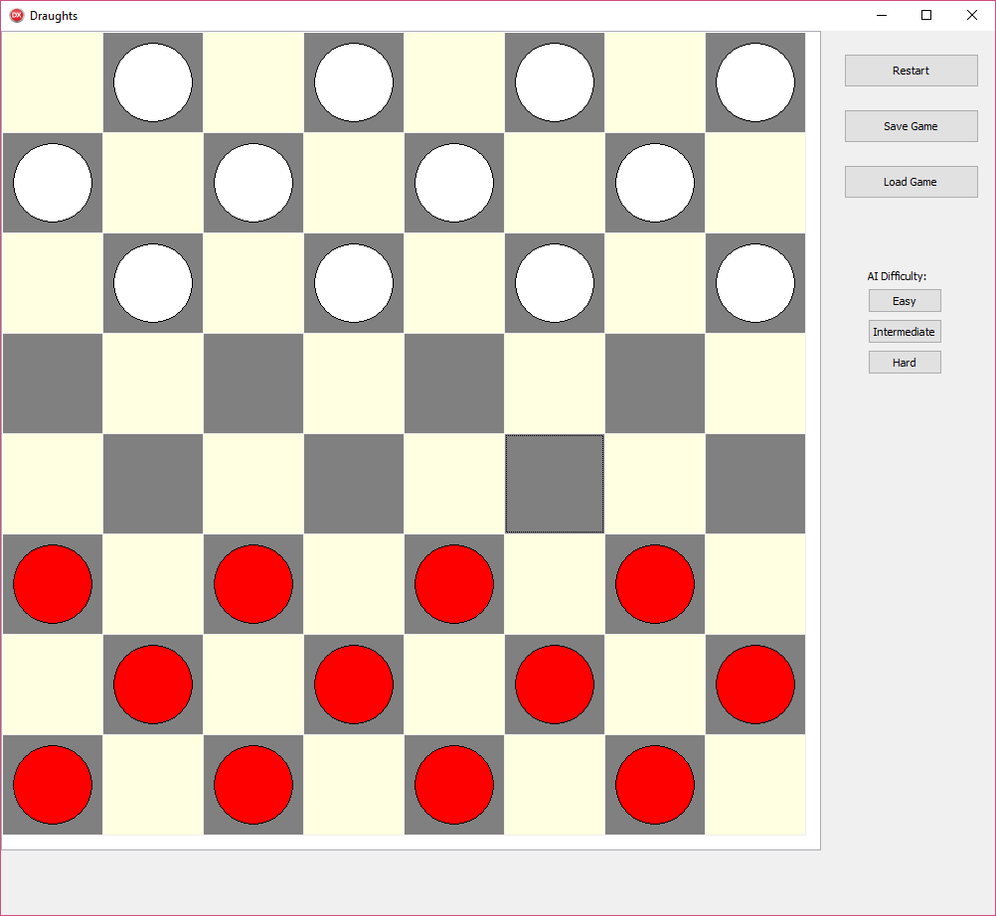

Feedback

Were all the objectives (above) met, if not, where was the project lacking?

What are the advantages my program compared to standard Draughts programs (i.e. an online draughts game)?

Were there any problems/shortcomings in my program?

If so, what improvements can be made?